COOPER CITY OPTIMISTS BASKETBALL
BRONZE DIVISION
SUMMER 2001

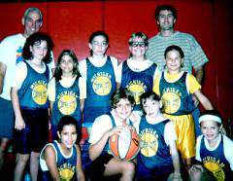
WE’RE THE MICHIGAN WOLVERINES!

MOST VALUABLE PLAYER AWARD

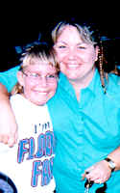
REBECCA WEISS

Jeremy Montague, Head Coach___________________
20 July 20011
COOPER CITY OPTIMISTS BASKETBALL
BRONZE DIVISION
SUMMER 2001

WE’RE THE MICHIGAN WOLVERINES!

OUTSTANDING TEAM PLAYER AWARD

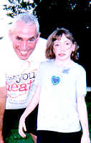
CHRISTINE MURPHY

Jeremy Montague, Head Coach___________________
20 July 2001
COOPER CITY OPTIMISTS BASKETBALL
BRONZE DIVISION
SUMMER 2001

WE’RE THE MICHIGAN WOLVERINES!

MOST IMPROVED REBOUNDER AWARD


KRISTIN MONTAGUE

Jeremy Montague, Head Coach___________________
20 July 2001
COOPER CITY OPTIMISTS BASKETBALL
BRONZE DIVISION
SUMMER 2001

WE’RE THE MICHIGAN WOLVERINES!

MOST IMPROVED REBOUNDER AWARD

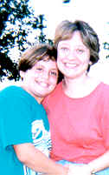
JANELLE ALONGI

Jeremy Montague, Head Coach___________________
20 July 2001

COOPER CITY OPTIMISTS BASKETBALL
BRONZE DIVISION
SUMMER 2001

WE’RE THE MICHIGAN WOLVERINES!

OUTSTANDING REBOUNDER AWARD

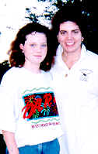
STEPHANIE HOCKE

Jeremy Montague, Head Coach___________________
20 July 2001

COOPER CITY OPTIMISTS BASKETBALL
BRONZE DIVISION
SUMMER 2001

WE’RE THE MICHIGAN WOLVERINES!

MOST IMPROVED DEFENDER AWARD

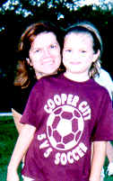
JACLYN BROMIR

Jeremy Montague, Head Coach___________________
20 July 2001

COOPER CITY OPTIMISTS BASKETBALL
BRONZE DIVISION
SUMMER 2001

WE’RE THE MICHIGAN WOLVERINES!

MOST IMPROVED DEFENDER AWARD

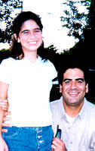
CHRISTINA DEVARONA

Jeremy Montague, Head Coach___________________
20 July 2001

COOPER CITY OPTIMISTS BASKETBALL
BRONZE DIVISION
SUMMER 2001

WE’RE THE MICHIGAN WOLVERINES!

MOST IMPROVED PLAYER AWARD

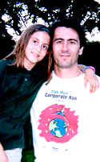
SAMANTHA COOKE

Jeremy Montague, Head Coach___________________
20 July 2001

COOPER CITY OPTIMISTS BASKETBALL
BRONZE DIVISION
SUMMER 2001

WE’RE THE MICHIGAN WOLVERINES!

OUTSTANDING DEFENDER AWARD

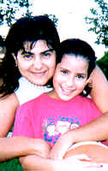
ANGELA CADAVID

Jeremy Montague, Head Coach___________________
20 July 2001

COOPER CITY OPTIMISTS BASKETBALL
BRONZE DIVISION
SUMMER 2001

WE’RE THE MICHIGAN WOLVERINES!

MOST IMPROVED OFFENSIVE PLAYER AWARD

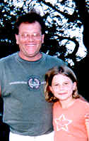
SARA SCHNEIDER

Jeremy Montague, Head Coach___________________
20 July 2001

